**Work Breakdown Structure**

Unfortunately I am not able to download my work breakdown structure (WBS) off of the website I used to create it (Asana), so I have taken screenshots instead.

Here is the first part:

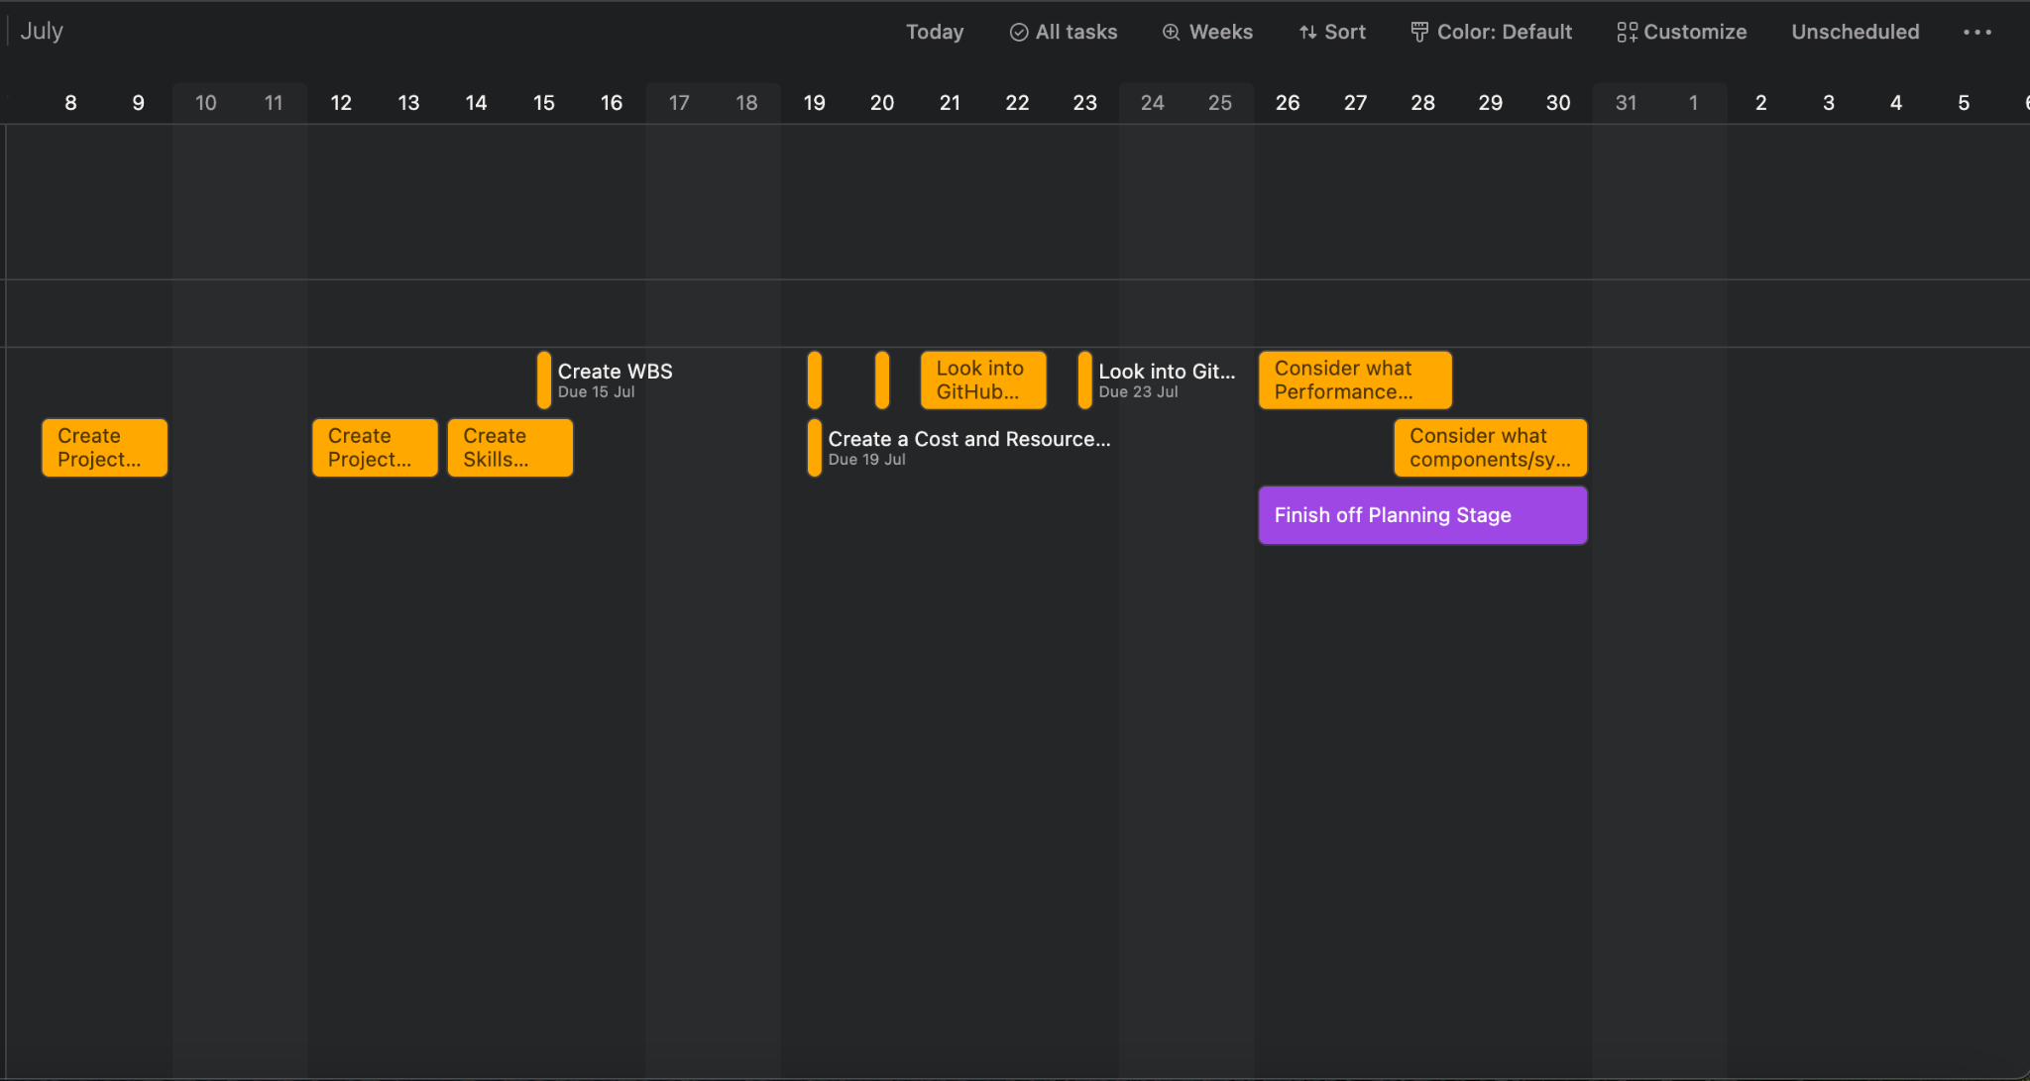

Here is the Second part:

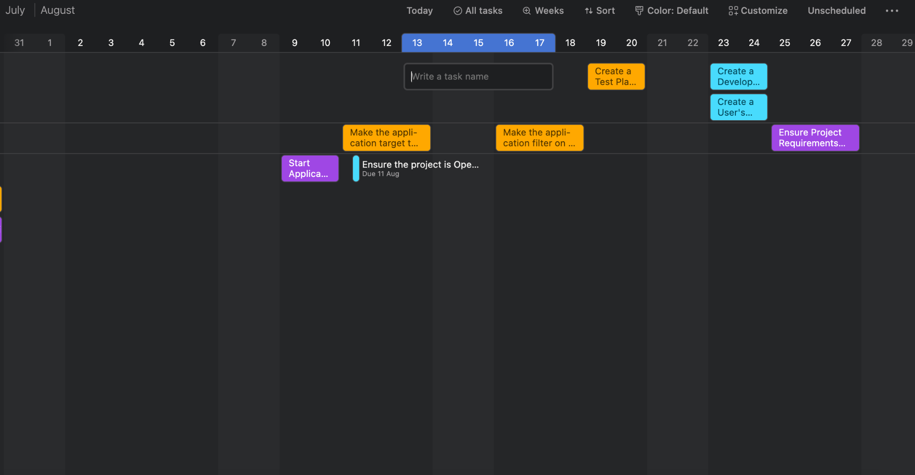

Here is the last part:

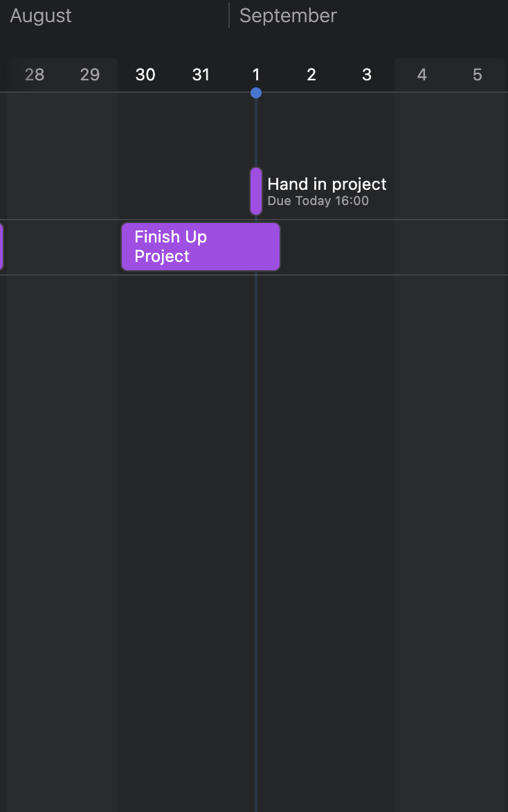

As you can see, the WBS allows me to set out goals that I should achieve by a certain date in order to complete the project in time. It also allows me to colour code those goals based one how important they are, the first colour is light blue which is “Low”. This is used for goals that are either very easy to do or goals that the project can still work if I do not do. The next colour is orange which is “Medium”. This was the standard colour for a lot of the goals, it is used for goals that need to be completed for the project to work but aren’t extremely hard. It was also used for goals where the timing was a bit flexible, as it didn’t matter if I started these goals a bit later then set out. The final colour was purple, which is “High”. These goals had to be started by the specified time and had to be finished by the specified time otherwise the project would not work. “High” was used for goals that were either going to be challenging or had a strict deadline. You can also move the goals into three categories, To Do, Doing and Complete so you can track what goals you are doing and what you’ve got left to do.